Prerequisites:
- Beam to Hall D must be OFF when powering up the Tagger magnet.
- Open the Hot Check Out (HCO) Tool and select/apply as a beam destination Hall D: (https://accweb.acc.jlab.org/hco/readiness?destinationId=9&regionId=&groupId=)
Verify the Tagger has completed the Hot Checkout Process and is prepared to be powered up.
(JLab > CEBAF > Magnets > Box Supply > Dipoles > MTGAD00)
(JLab > Hall D > Hall D Photon Beam > Hall D Tagger Magnet > Hall D Tagger Power and Vacuum)
- Use eDT (JTabs > Operations > Optics > Magnets > eDT) to download the appropriate set point and tuning limits per the Hall D Beam Delivery Procedure if this is the first time setting up that Hall after a significant period of downtime (> 1 week).

Procedure Steps:
1.0 Turning On the Tagger Magnet Power Supply and Setting the Initial Magnet Current
- Verify that beam to Hall D is OFF.
- Open the Crosspoint Video Control Screen (JTabs > Operations > Viewers (Video) > DVR), and connect to the Accelerator Viewer channel.
- Open the Bluecherry Web Interface and left click on LiveView. ‘Click to select a camera’ and select the channel corresponding to the Crosspoint DVR channel you selected in (2).
- Insert the Tagger dump viewer, ITVAD00.
- Open the Tagger Magnet Controls screen. (JTabs > Operations > Magnets > Hall D > Tagger Magnet (MTAG5C)).

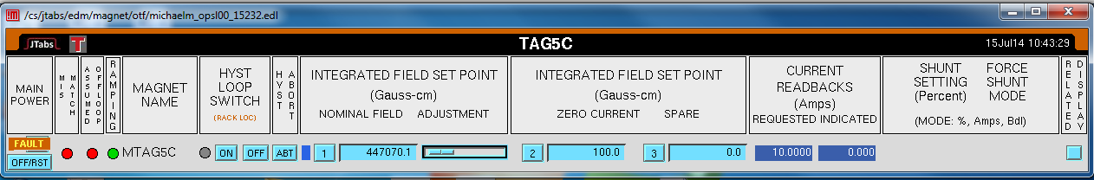
(Figure 1-1: Tagger Magnet Power Supply Control Screen)

- Under Integrated Field Set Point select set point ‘2’ for the zero current value of the supply.
- Ensure the Hysteresis Loop Switch is set to OFF.
- Under the Main Power Column select and hold OFF/RST for 5 seconds. This issues a reset command to the supply. If there is a fault present (as in Figure 1-1) it should clear displaying the ON button.

If there was a fault, did it clear?
Yes No > Open the Box Supply Related Display Screen. Using this expert Proceed to step 9. screen, evaluate and correct any errors present with the aid of your
crew.
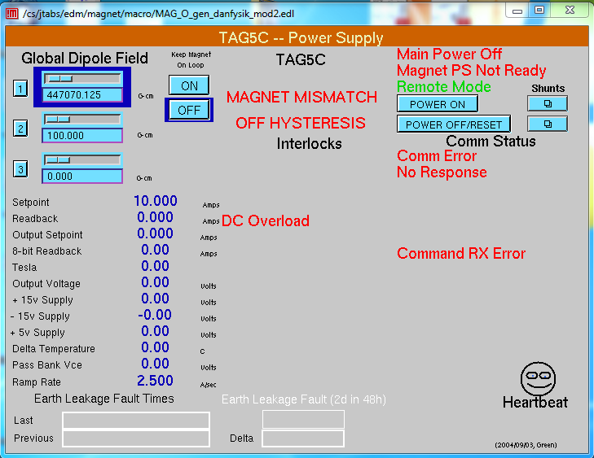
(Figure 1-2: Tagger Magnet Power Supply Expert Screen)

Were you able to clear any errors?
Yes > Repeat step 7.
No > Contact EES-DC for further assistance.
- Click ‘ON’ to turn on the power supply at zero current.
- Once the supply is on, select the Nominal Field set point (Set point “1”)
- Put the Hysteresis Loop Switch ON. This will put the Tagger through the appropriate Hysteresis cycle and place it on loop in at the set point.
- Unmask the Tagger magnet FSD node on TSB001 (JTabs > Operations > FSD Overview > TSB001).
- Verify that the Tagger magnet alarm is enabled in the Alarm Handler (JTabs > Operations > Alarms > Alarm Disable Tool; see Figure 1-3 below). If it is disabled (black indicator), enable it now.

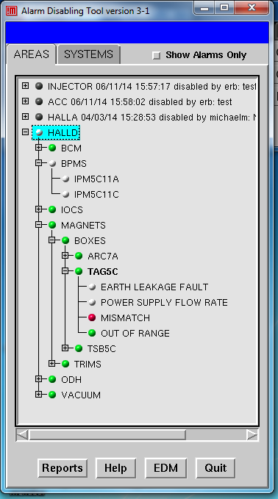
(Figure 1-3: The Alarm Handler)

2.0 Adjusting the Tagger Magnet Current Setting and Steering on the Dump

Caution: Changes >1% in the Tagger Magnet set point must be made using the automatic hysteresis procedure described in Section 1.0 of this procedure. Beam to Hall D must be OFF when such changes are made.

  - Take the Tagger Magnet Power Supply off Hysteresis by setting the Hysteresis Loop Switch to OFF.
  - To adjust the magnet current by small amounts (< 1%), either enter the new set point directly into the current set point field for position 1, or move the slider bar. If you are using the slider reduce the sensitivity to steps of no greater than 10⁻¹ Amps.
  - Refer to the Tagger Dump video monitor, ITVAD00, and IPMAD00 for the beam position. IHAAD00 may be used to help locate beam if necessary.
  - Turn beam OFF to hall D and cycled the Tagger Magnet Power Supply by setting the Hysteresis Loop Switch to ON at the new set point.
  - Turn beam on (at the discretion of the crew chief, and in accordance with the operational restrictions) and verify that your results have reproduced; make changes if necessary.

3.0 Setting up the Tagger Magnet before an Access.
  - When an access is required, stop beam delivery and close the Hall D beam slit.
  - Using the FSD masking tool (JTabs > Operations > FSD > FSD Overview > Masking Tools (!) > Ops), mask the accelerator for the appropriate beam destinations without Hall D (This depends on the current accelerator configuration, ask the crew chief if this is in question)
  - Clear FSD faults and restore beam to other destinations at the discretion of the crew chief.
  - Take the Tagger off of its hysteresis loop by selecting HYST Loop Switch OFF.
  - Select Integrated Field Set Point number “2” for the Zero Current setting of the Power Supply.
  - Once the Current Read Back Indicated field reaches zero, from the Main Power column select the OFF/RST button. This will power down the supply, and allow the Hall to proceed with an access as required.

(Section 4.0 Degaussing… is a degaussing routine desired? Should it be done every shut off? What is the preference of the Hall?)

