TITLE: WRAP THE SCINTILLATOR WITH MYLAR AND COVER WRAP | DATE: 09/26/2013
BY: WILLIAM CRAHEN | APP: ___________________________
 | PRINT: _________________________
CHK:______________________  PRINT: ____________________ | APP: ___________________________  PRINT:_________________________

REV. | DESCRIPTION | BY | CHK. | APP. | APP. | DATE

PREPERATION
Safety Equipment Required:
Work Area Requirements:

The work area should be well ventilated with good lighting. There should be no adjacent activities that generate particles/dust or aerosol contaminants.
# of Technicians Required:
1

Material Required:

Scissors
3M super 33+ electrical tape, ¾” wide
Guillotine paper cutter (New or recently sharpened) note: use this cutter for cutting Mylar and Tedlar only.
3/4” wide 3M 810 Scotch MAGIC tape
48 Gauge (12 micron/.00048” thick) aluminized Mylar
Ethanol or Isopropyl
Lint Free wipes

Scales

Note: Either Latex or Nitrile gloves can be used for this procedure.

Safety glasses with side shields are required when working with Alcohol
Procedure

- Clean the light guide end and scintillator with Alcohol and a lint free wipe. Allow to dry.

- Use the Guillotine cutter to make a Mylar rectangle that is 1.57” (4cm) by approx. 4” long. Wrap the scintillator end as shown and secure with Scotch tape:

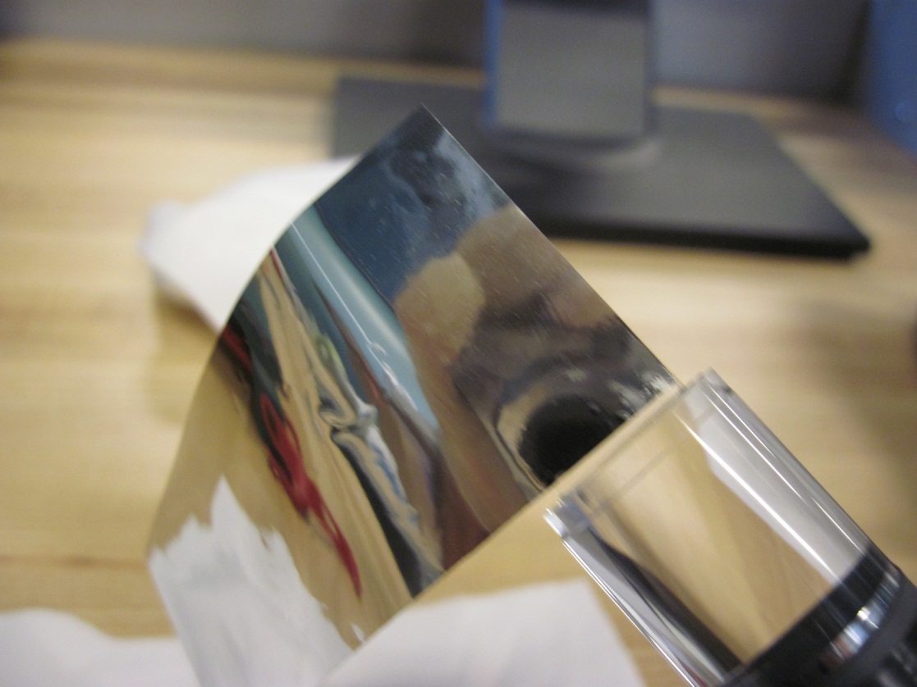

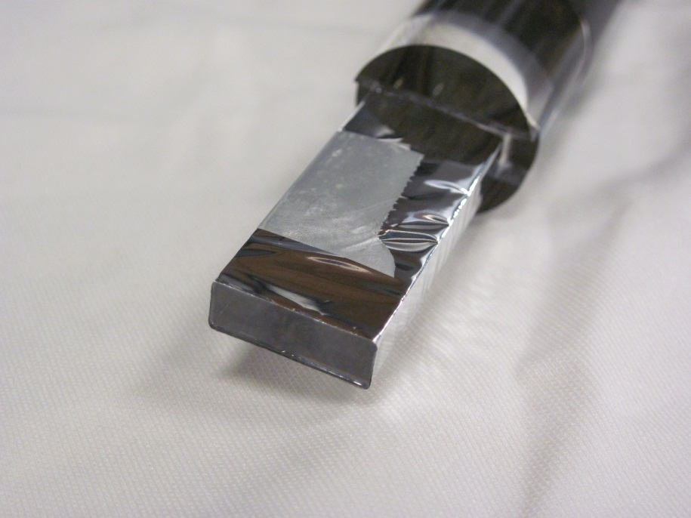

3. Measure the width shown below and cut a piece of Mylar as shown in the lower photo:

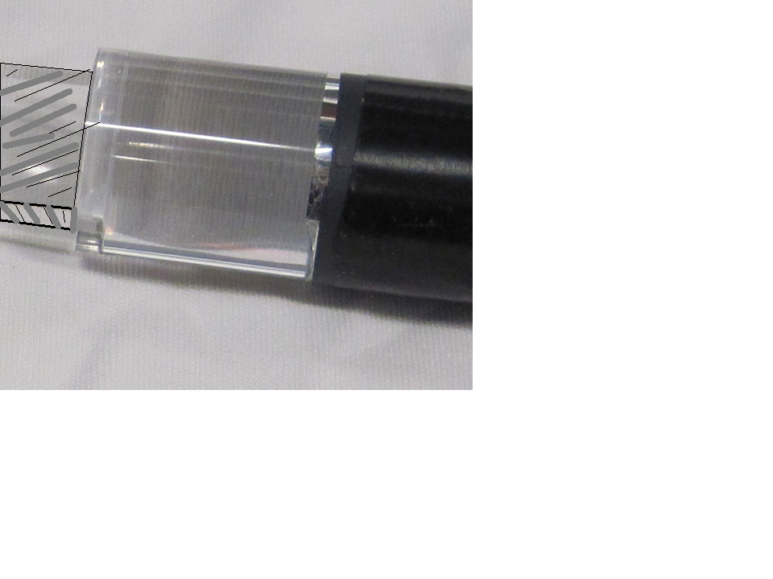
1/2”
Slits
‘W’
11”
W
5.5”

- Wrap as shown in the following photos:

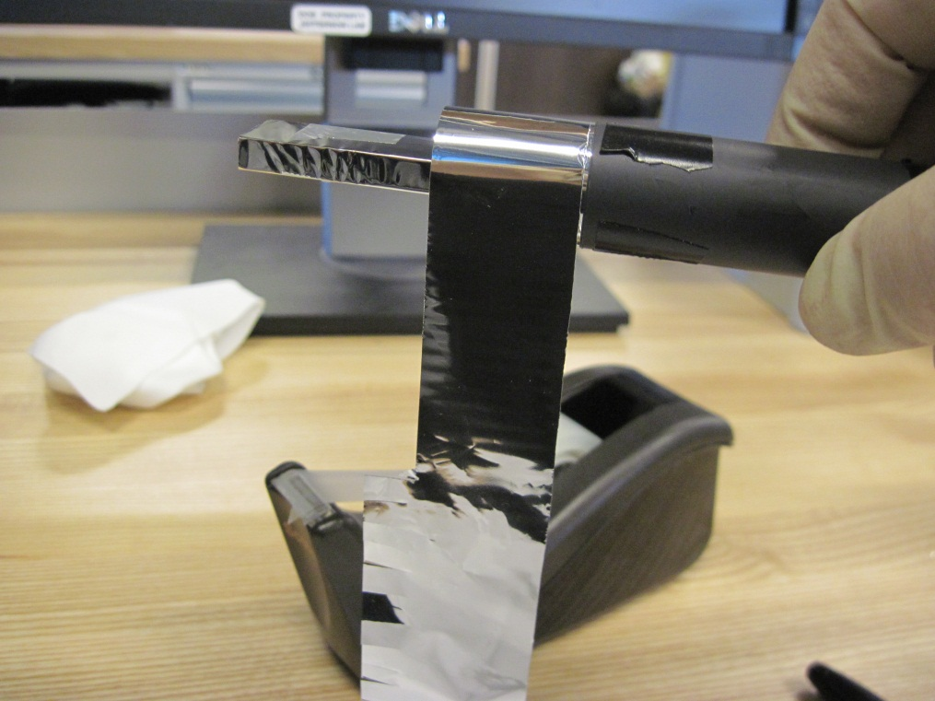
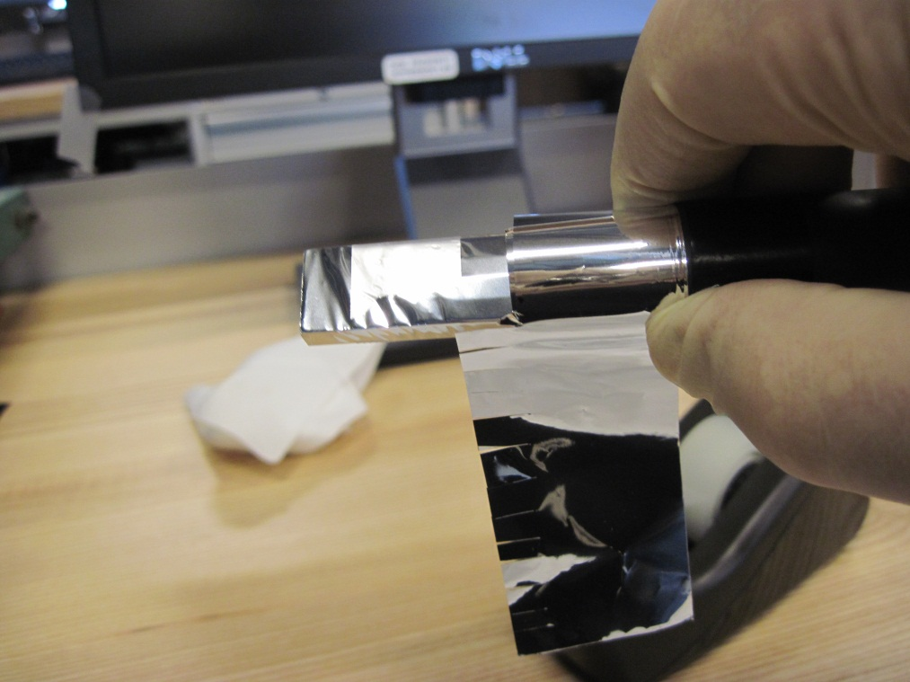

- Secure with scotch tape. The wider section of the mylar with the slits extends beyond the light guide edge. Cut two pieces of electrical tape ~1” long. Stretch each of the electrical tape pieces as shown in the lower photo, forcing the Mylar “fingers” down:

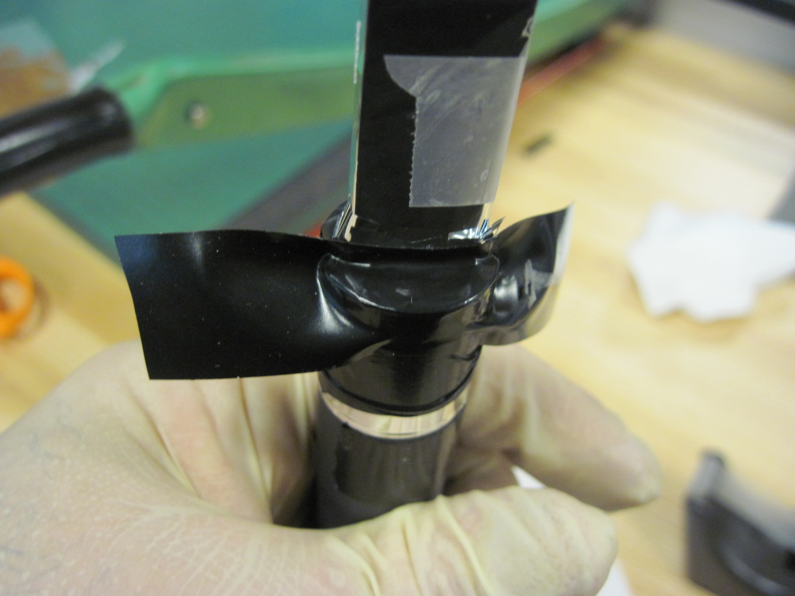

- Cover the end of the scintillator with a piece of Mylar and secure with scotch tape:

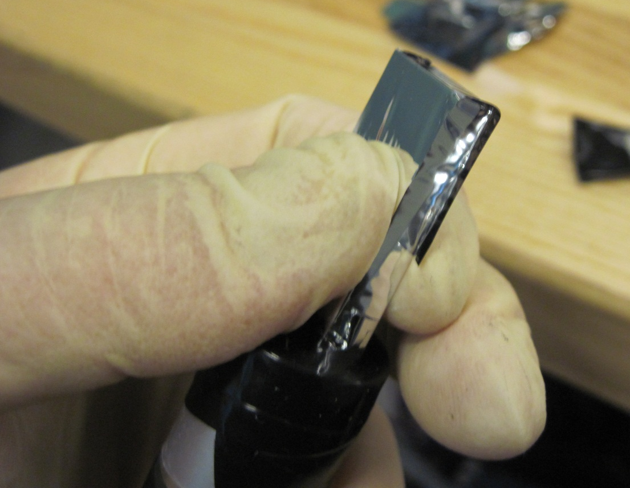

- Over wrap the Mylar with electrical tape. Use only two layers, and take care not to have clumpy built up areas on the scintillator (the added thickness could inhibit performance);

