TITLE: POSITION CLAMP COLLAR ON HODODSCOPE LIGHT GUIDE | DATE: 09/18/2013
BY: WILLIAM CRAHEN | APP: ___________________________
 | PRINT: _________________________
CHK:______________________  PRINT: ____________________ | APP: ___________________________  PRINT:_________________________

REV. | DESCRIPTION | BY | CHK. | APP. | APP. | DATE

PREPERATION
Safety Equipment Required:
Work Area Requirements:

The work area should be well ventilated with good lighting. There should be no adjacent activities that generate particles/dust or aerosol contaminants.
# of Technicians Required:
1

Material Required:

3M #471 Vinyl tape (3/4” wide- for the light guide clamp area. This tape is .004” thick)

Tooling Assembly D00000-07-01-1070 (including two 1/8” diameter dowel pins and the Nylon split collar half)

Ultra-Soft Polyurethane .06” thick (McMaster Carr 8824T12) to line the surface of the split collar.

Split collar D00000-19-01-2013

Hodoscope PMT/Scintillator assembly

Scales

Note: GLOVES MUST BE NITRILE, NOT LATEX! LATEX INTERFERES WITH CURING OF THE SILICONE.

Procedure

- Note the configuration of the tooling fixture. Red area is four layers of the specified Vinyl tape, which equates to a total thickness of .016”. If this area is damaged or marred, replace the tape. Note the positions of the two ½” long 1/8” dia. dowel pins:
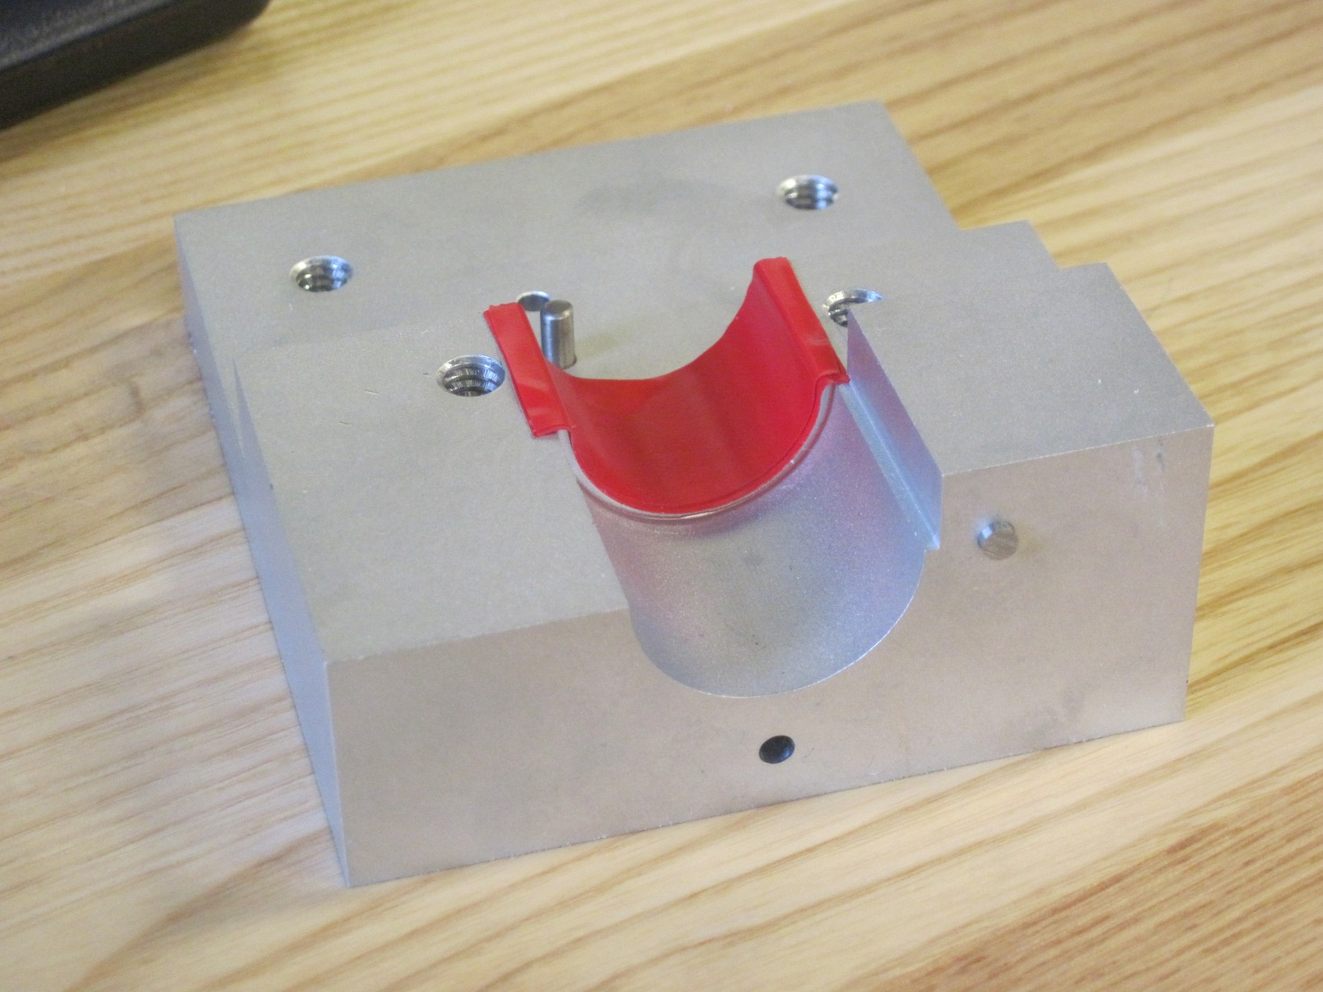
This pin must not protrude more than .060”
Pins

- Slide the Rectangular plastic block onto the light guide, and position the assembly as shown below in the fixture:

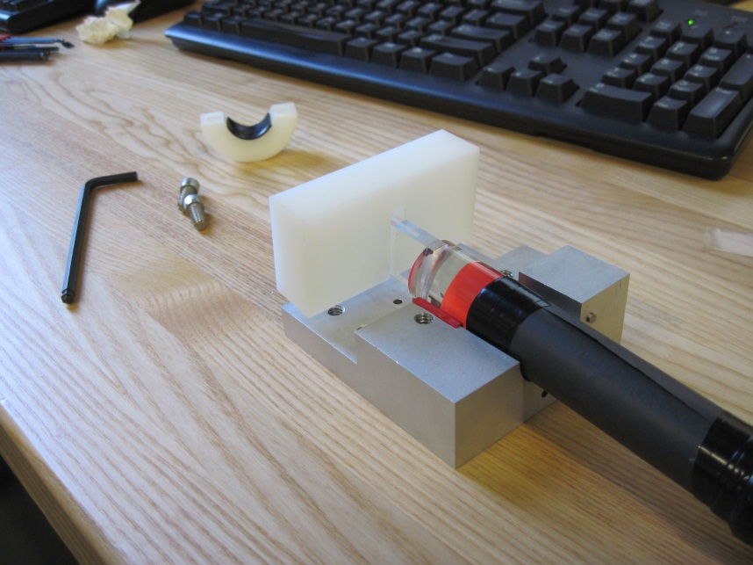
Note the Sorbothane on the split collar face

The end of the light guide contacts the dowel pin. The plastic block orients the guide:
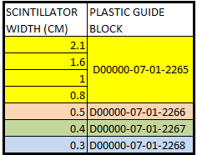
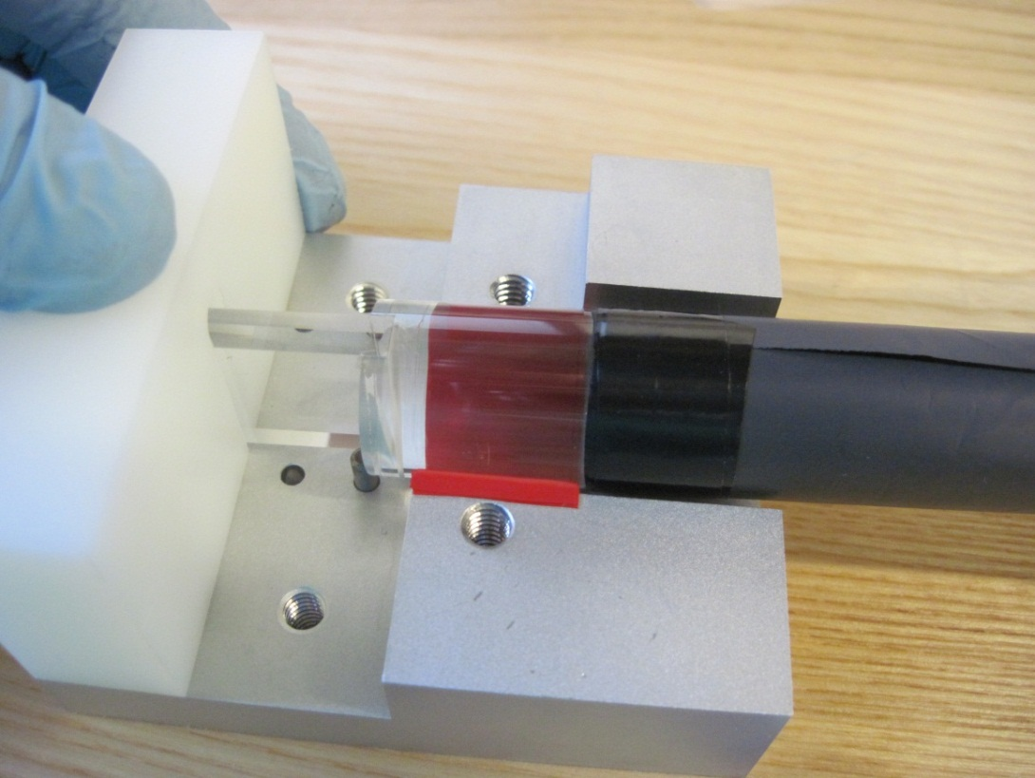

- Add the half of the split collar. Tighten it evenly on both sides to just hold the light guide snug- do not over torque:
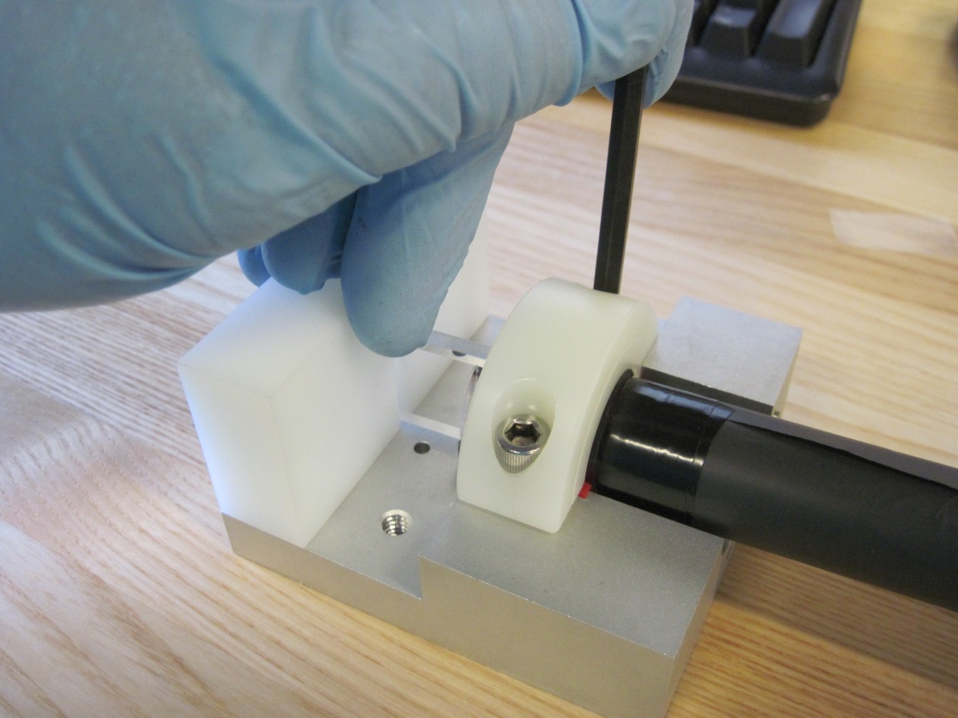

- Assemble the split collar D00000-19-01-2013 loosely as shown:
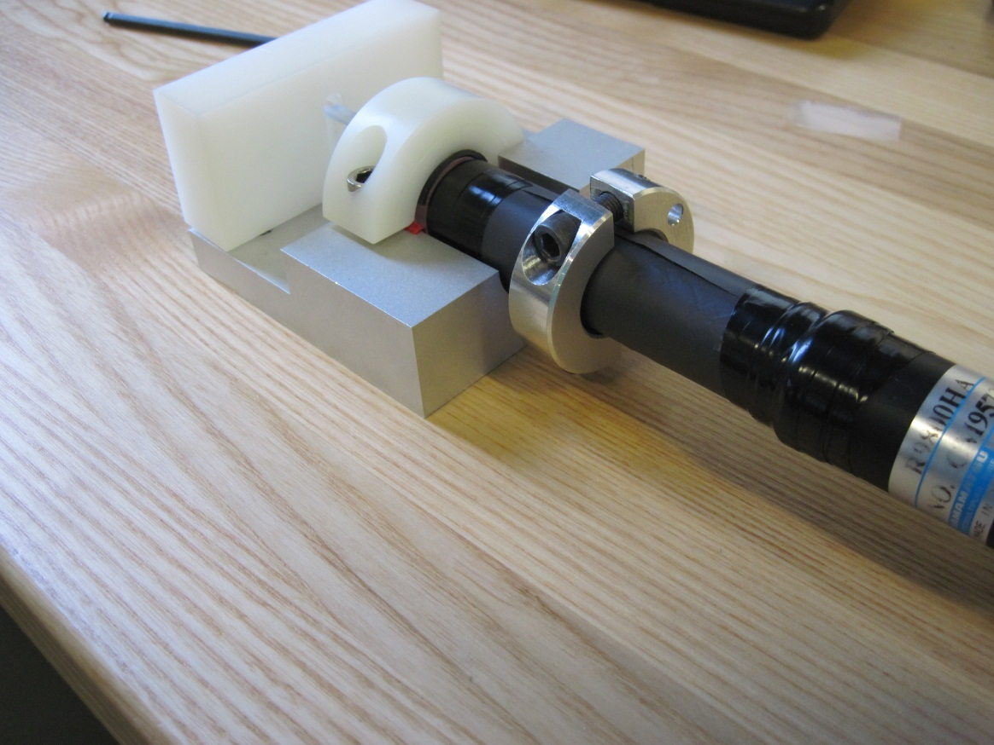
- Hold the tapped collar side against the face of the fixture and the surface of the light guide with the slot positioned over the dowel pin as shown below. Evenly tighten the collar to a bolt torque of approximately 30 in-lbf:

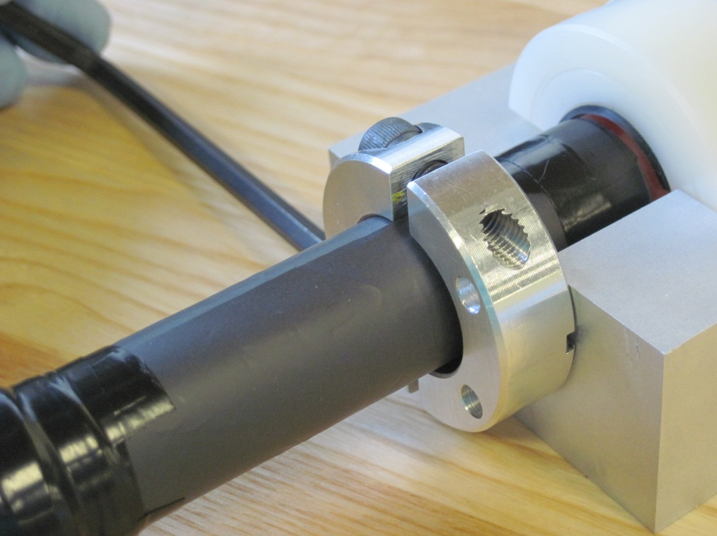

- Remove the nylon split collar and the Plastic block, and inspect the assembly. Store in a light tight enclosure until the next step:
