TITLE: GLUING THE HALL D HODOSCOPE PMTS TO THE LIGHT GUIDES | DATE: 09/17/2013
BY: WILLIAM CRAHEN | APP: ___________________________
 | PRINT: _________________________
CHK:______________________  PRINT: ____________________ | APP: ___________________________  PRINT:_________________________

REV. | DESCRIPTION | BY | CHK. | APP. | APP. | DATE

PREPERATION
Safety Equipment Required:
Work Area Requirements:

The work area should be well ventilated with good lighting. There should be no adjacent activities that generate particles/dust or aerosol contaminants.
# of Technicians Required:
1

Material Required:
Momentive RTV 615 2 part Silicone (mix ratio 10:1 by weight)
Momentive SS-4120 Primer
3- Beam scale or equivalent (accurate to .1 gram)
1 oz polypropylene mixing Cups (McMaster Carr 1865T33 or equivalent)
Plastic Mixing stick
3ml syringe with Luer lock connection (McMaster Carr 7510A651 or equivalent)
20 Gauge tapered Luer lock tip (McMaster Carr 6699A4 or equivalent)
Lint free wipes (cut into ~4” squares)
Isopropyl Alcohol
#64 rubber bands
PMT gluing fixture D00000-19-01-XXXX
Temperature controlled oven large enough to accommodate 3 sets of tooling (set point 40°C)
Vinyl tape (to cover Vblock surfaces)
Bell Jar and vacuum pump for De-gassing the mixture.
Nitrile gloves

Scales

Note: The Momentive products DO NOT require refrigeration in between use.

Set the oven to 40 Celsius at the beginning of the process to allow pre-heat time.

Use a bubble level to check in advance that the gluing fixture is vertical when on the work table and when placed in the oven. Shim/adjust as required.

Note: GLOVES MUST BE NITRILE, NOT LATEX! LATEX INTERFERES WITH CURING OF THE SILICONE.

Procedure

- Use a lint free wipe to clean both the PMT and the light guide with Isopropyl Alcohol. Attach the PMT(s) to the Gluing fixture with #64 rubber bands as below. Note that there is a slightly larger diameter at the very top of the PMT (shown in lighter gray). This lip must be above the end of the Vblock for proper centering:
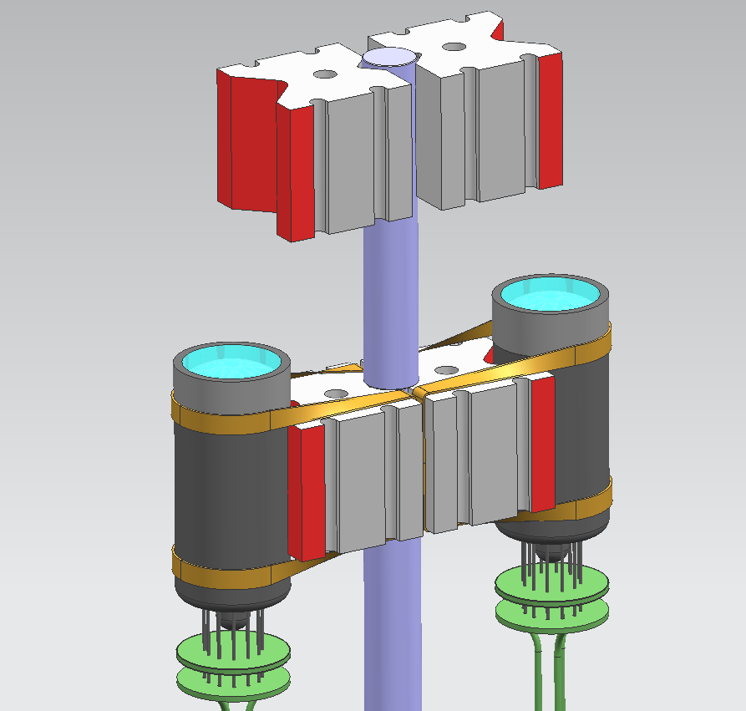
Rubber band
Larger diameter at end of PMT
Vblock faces
Covered with Vinyl tape

- Cut a lint free wipe into a ~4” square. Dampen the square with primer SS-4120 and wipe the bond surfaces of the light guide and the Hamatsu PMT. Allow both to dry for one hour (shield the PMT from light while drying). While this material is drying, proceed to mix the Silicone components as per following steps.

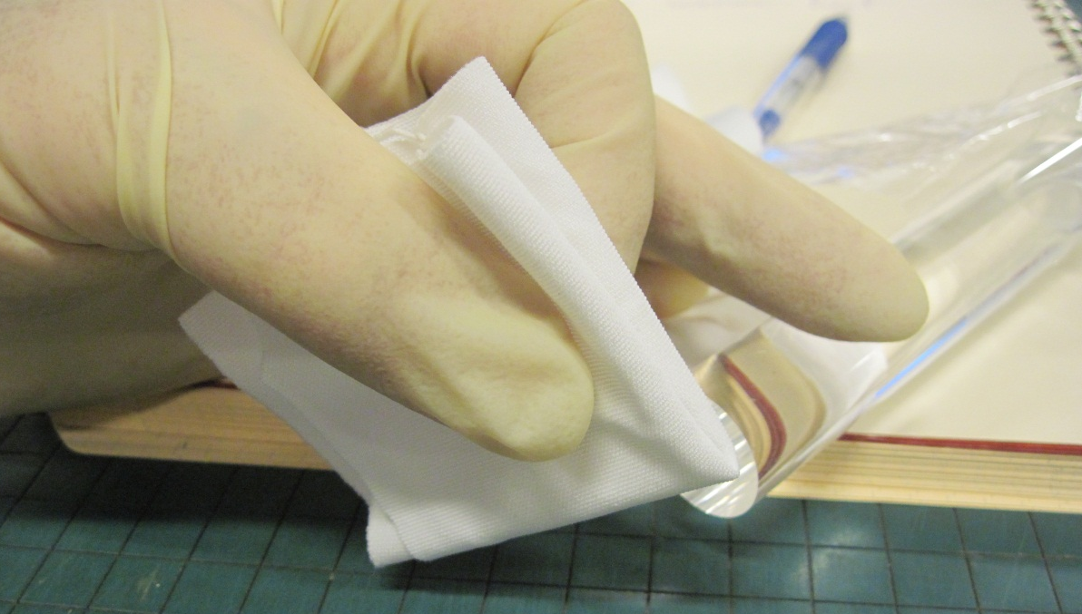

- Record the tare weight of an empty mixing cup on the Three-Beam scale. Carefully pour 1.5 grams of the Silicone Resin for each PMT to be assembled to the mixing cup (recommended minimum of 3 grams):
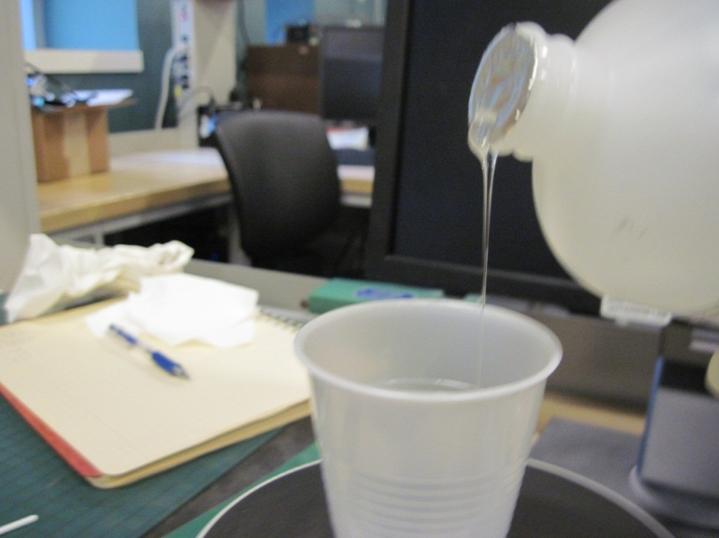

- Multiply the weight of the resin added by 0.1 to determine the weight of hardener required. Set the scale to this final value. The published specific gravity of the hardener is ~1.0 so this is also the number of milliliters required to reach this weight. Use a 3ml syringe with a 20 gauge tip to add this amount to the cup, until the desired weight is achieved.
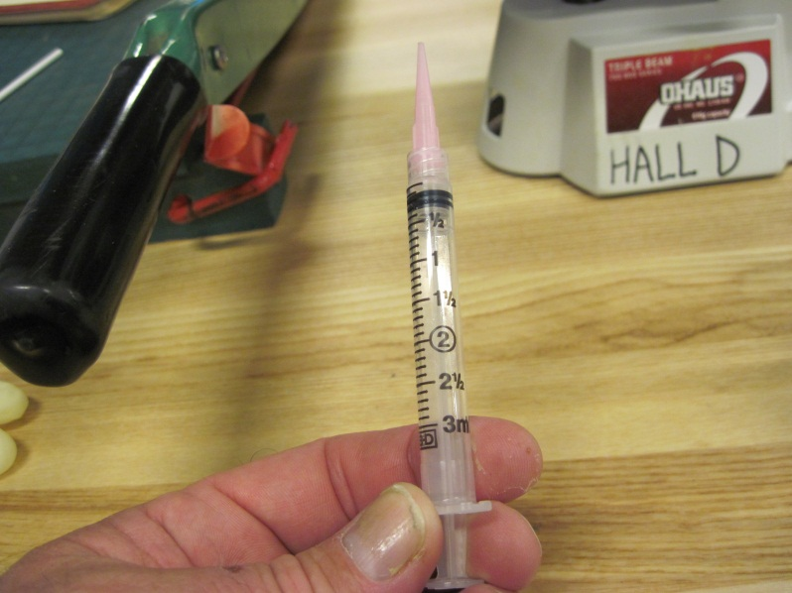

- Use the plastic mixing stick to combine the components. Stir the mixture for a minimum of 2 minutes, and then place in the bell Jar to de-gas the mixture. Note- the bell jar should have a tee fitting in the vacuum line connected to a metering valve. This is necessary to ‘bleed up’ the jar SLOWLY after degassing. if you were to simply disconnect the hose, the sudden inrush of air would blow the mixing cup over. An alternate approach is to tape the cup to something heavy. The mixture should be degassed for approximately 30 minutes- this can be confirmed visually by the cessation of frothing and the disappearance of visible bubbles. Add three minutes to this time.

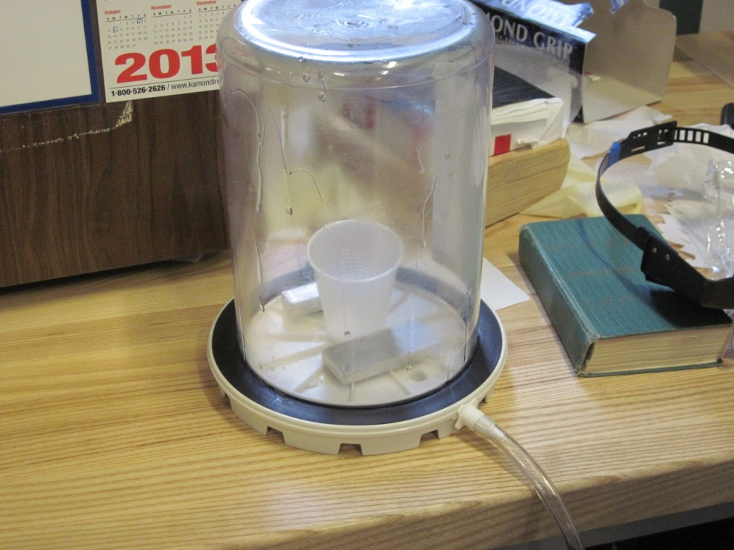

- Install the upper Vblock clamps and adjust to clamp against the light guide with a piece of 1/8” thick silicone rubber in between (piece shown is cut from silicone tube- McMaster 51135K64). Snug the clamp with a large gap between light guide and PMT:
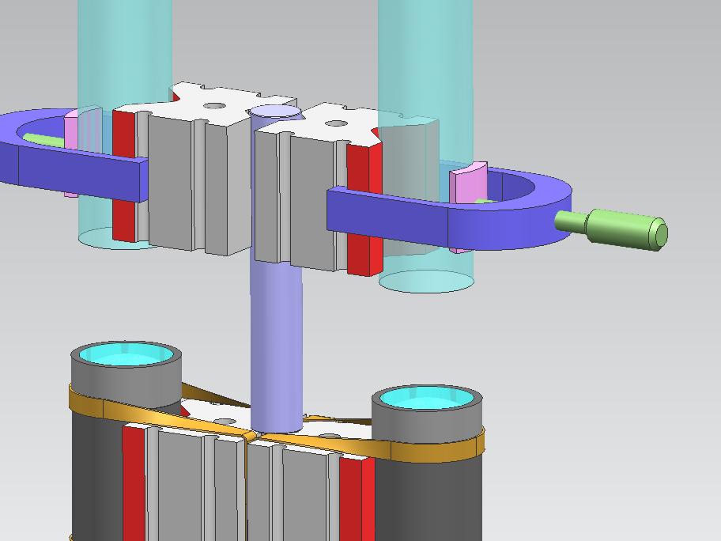
1/8” thick Silicone Rubber pad

- Use the small end of a plastic mixing stick to deposit 3 drops of the mixture on the center of the face of the PMT (let the drop fall off the stick onto the face). You want all the liquid in one spot, do not spread it as this could create potential cavities to trap bubbles in the next step:

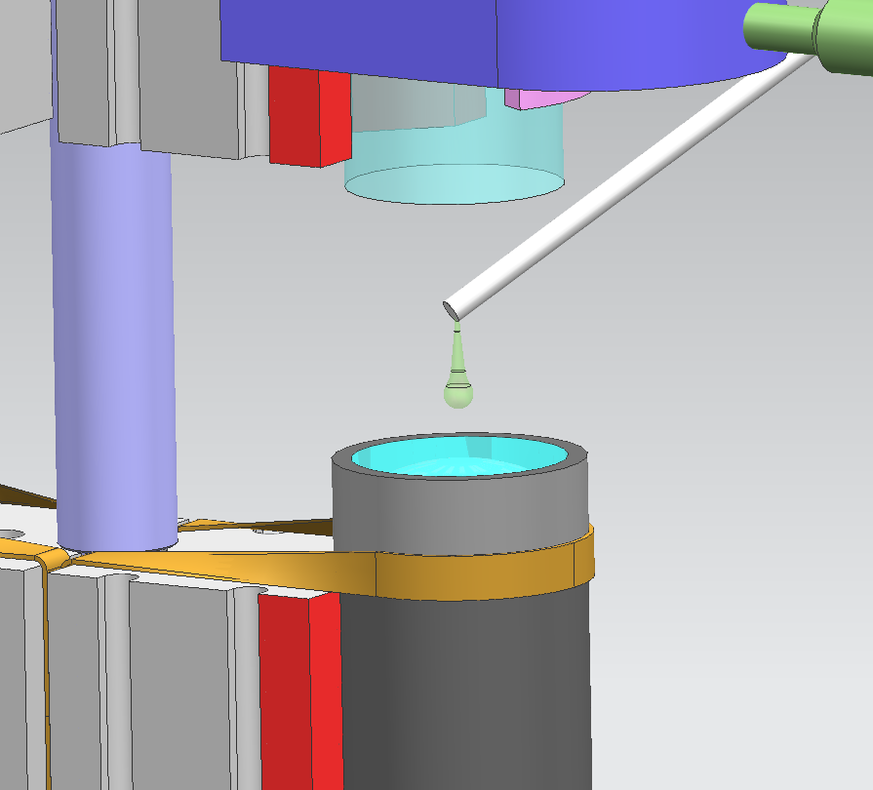

- Loosen the light guide clamp and slowly lower into contact with the silicone, while looking through the side of the light guide. You will be able to see if the wetted area is bubble free. Bring the light guide all the way down to contact the face of the PMT. Adjust the clamp so that it is snug against the light guide. Give the silicone a couple of minutes to settle/flow. Use the corner of a lint free wipe to remove any excess silicone that drips over the edge of the PMT.

- Transfer the Gluing fixture to the oven. Put the mixing cup with the remaining resin in oven as well, to be checked later to confirm solidification. Allow a minimum of 12 hours to cure.

- After curing, remove the assembly from the fixture and wipe down with Isopropyl Alcohol. Store the assembly in a light tight container until the next step.

