TITLE: ADD MU METAL TO THE HODOSCOPE COUNTER | DATE: 09/25/2013
BY: WILLIAM CRAHEN | APP: ___________________________
 | PRINT: _________________________
CHK:______________________  PRINT: ____________________ | APP: ___________________________  PRINT:_________________________

REV. | DESCRIPTION | BY | CHK. | APP. | APP. | DATE

PREPERATION
Safety Equipment Required:
Work Area Requirements:

The work area should be well ventilated with good lighting. There should be no adjacent activities that generate particles/dust or aerosol contaminants.
# of Technicians Required:
1

Material Required:

.004” thick Mu Metal foil cut to 5 ¼” by 10” (this gives three wraps- increase the 10” dimension if desired)
Scissors
Magic marker for laying out cut points on Mu Metal
7/8” diameter by ~6” long “mandrel” to form Mu Metal (wood dowel, plastic or metal cylinder)
3M super 33+ electrical tape, ¾” wide
2” wide Kapton tape
Double-sided Scotch tape ½” wide
1 3/8” wide .06” thick soft rubber (any material type) cut to 2.6” length. Material shown in the procedure is McMaster Carr 8825T12.
Guillotine paper cutter (New or recently sharpened) note: use this cutter for Mu Metal only as it will presumably dull the blade- Tedlar and Aluminized Mylar should be cut on a separate unit.

Scales

Note: Sheared Mu metal edges may be sharp. Thin protective gloves should be used in this procedure when handling the Mu Metal

Procedure

- Wrap the ends of the PMT and the circuit board as shown below. Cover this same area with a layer of Kapton tape:
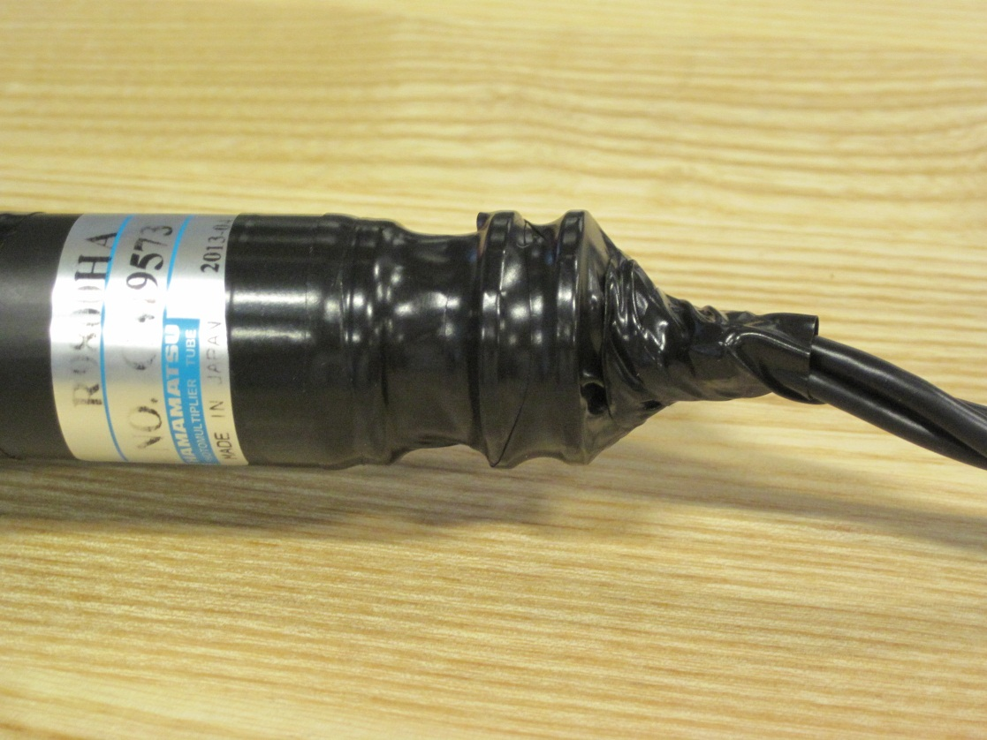
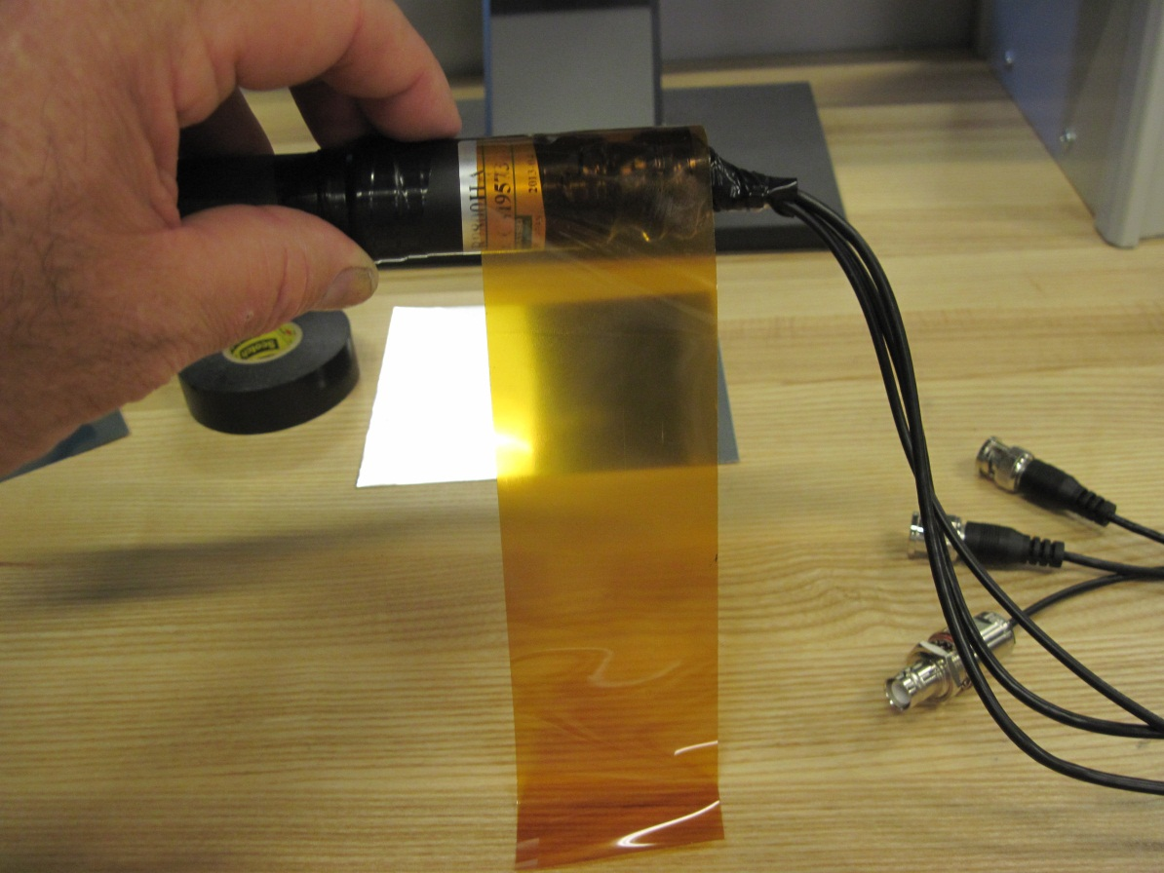
- Build up the area below the PMT with a 1 3/8” wide by 2.6” long rubber strip to the same diameter as the PMT(alternately use electrical tape). Over-wrap this with electrical tape:

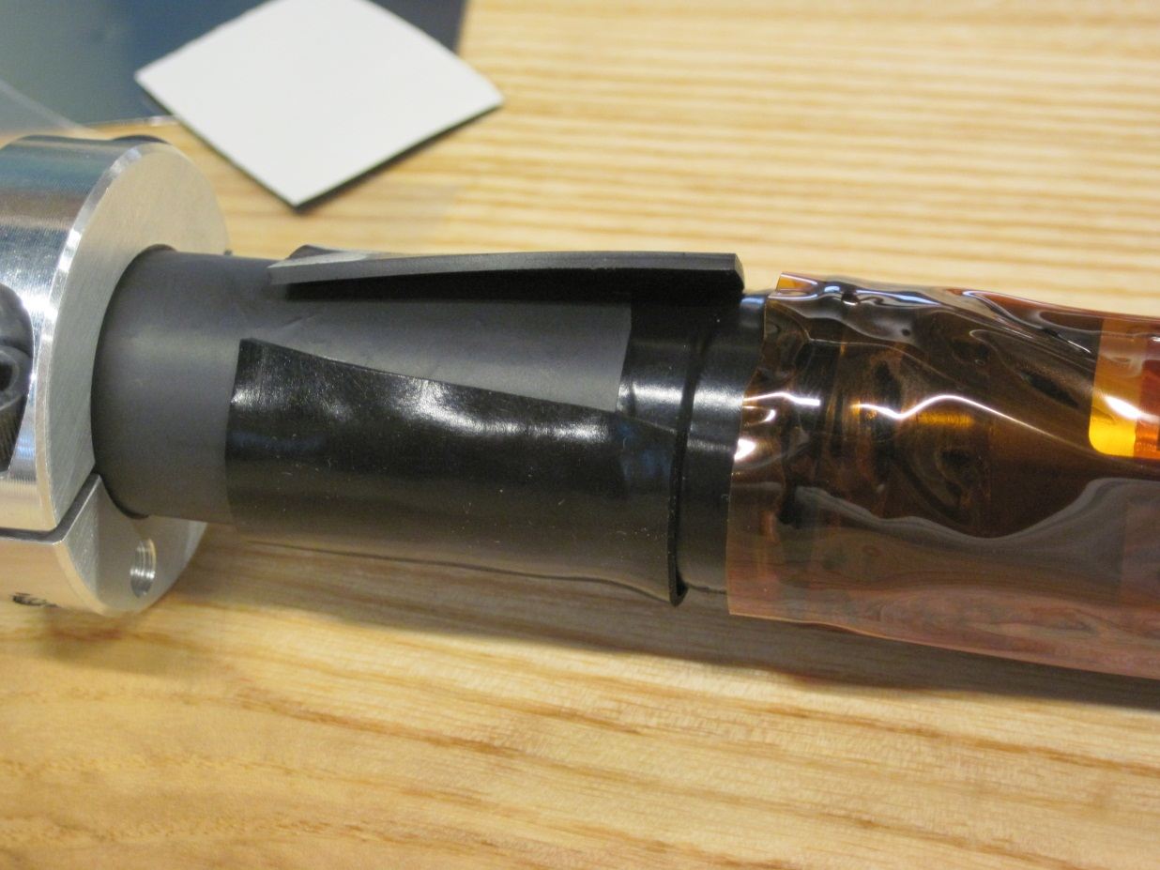
Do not build up this area
¾”

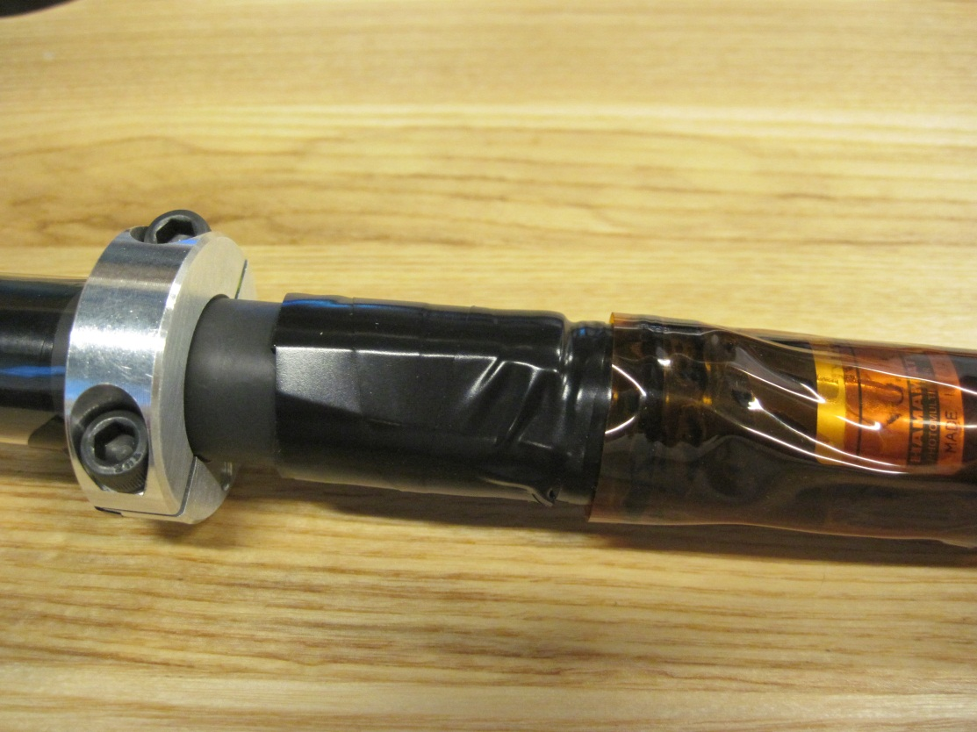

- Cut the Mu metal to 5 ¼” width with it’s dedicated Guillotine unit (the roll of Mu Metal shown is 15” wide- we used the full length for the sample counters):
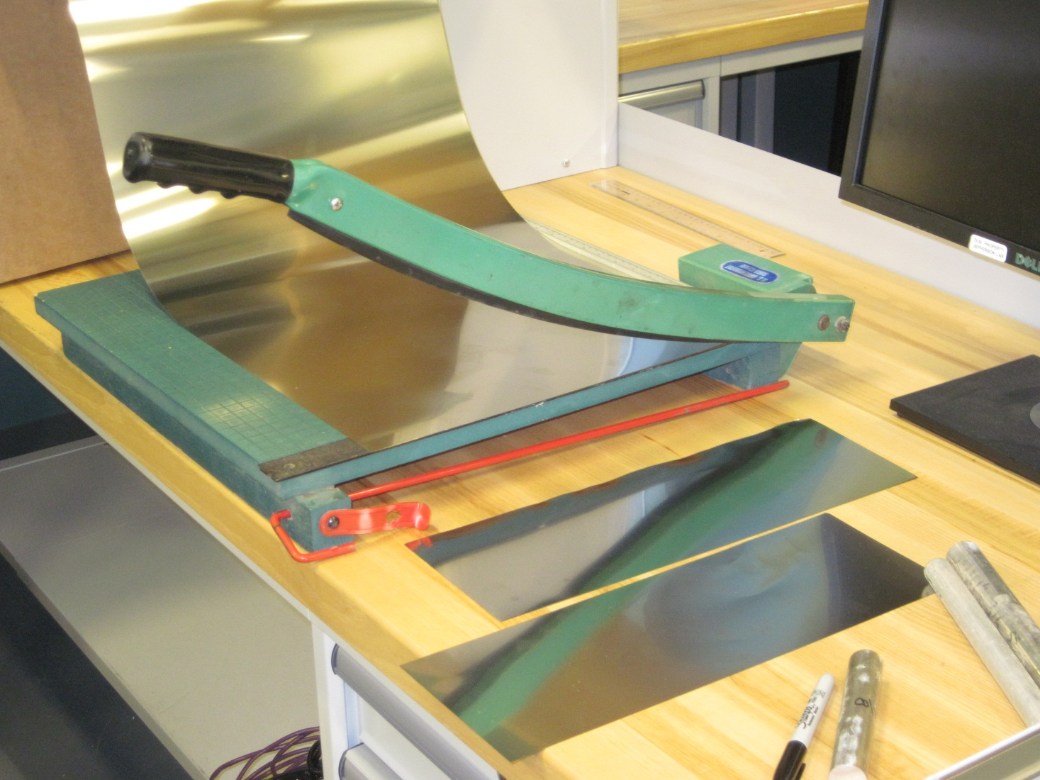

- Use the 7/8” diameter mandrel to form the Mu Metal. Be carful not to introduce additional wrinkles/creases in the surface:
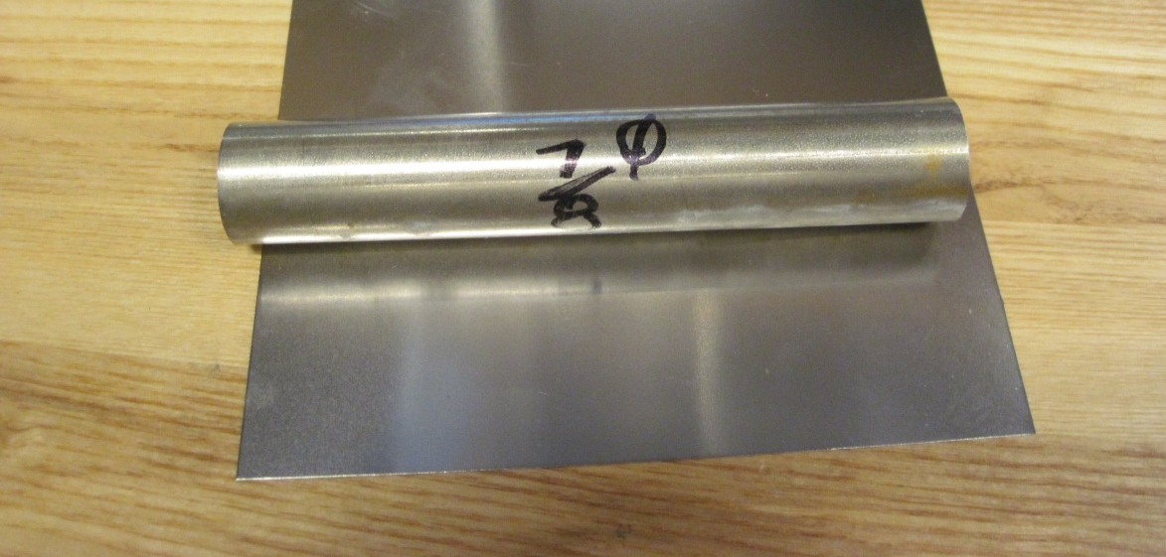

- Apply a strip of double sided scotch tape down the length of the PMT and built-up area as shown below:
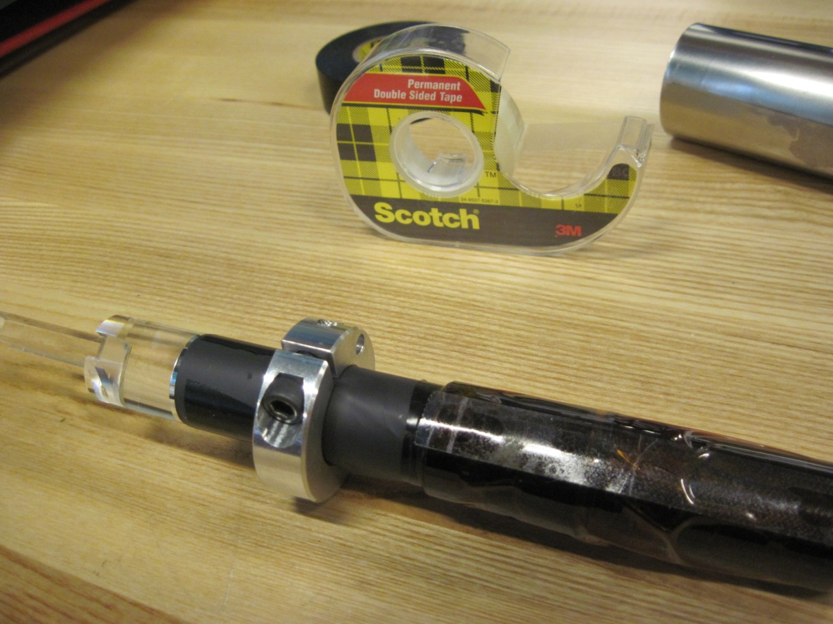

- Slide the formed coil of Mu Metal over the cables and the PMT,taking care to keep the inner surface away from the tape until located as shown below. At this time, press the coil down against the tape:
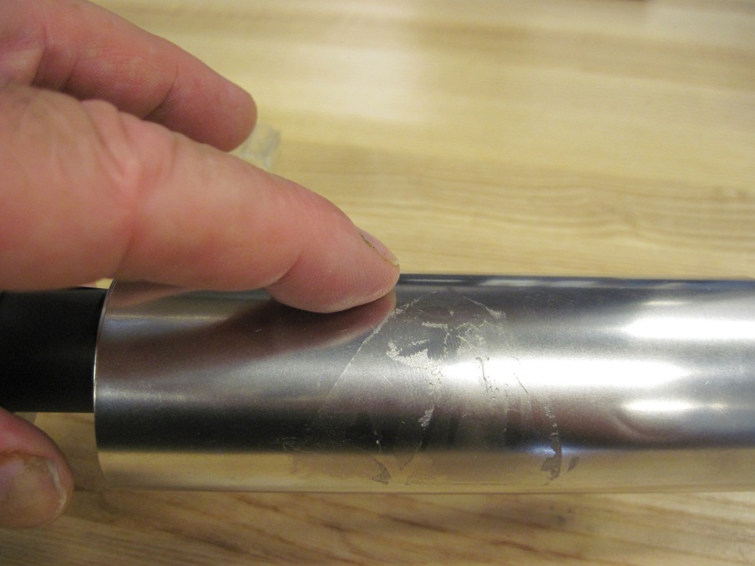

- The tape will hold the inner layer stationary while the coil is tightened by twisting. Secure the end nearest the clamp collar first with a piece of electrical tape, then secure the other end. Fold the edge of the electrical tape over the exposed edge of the Mu metal:
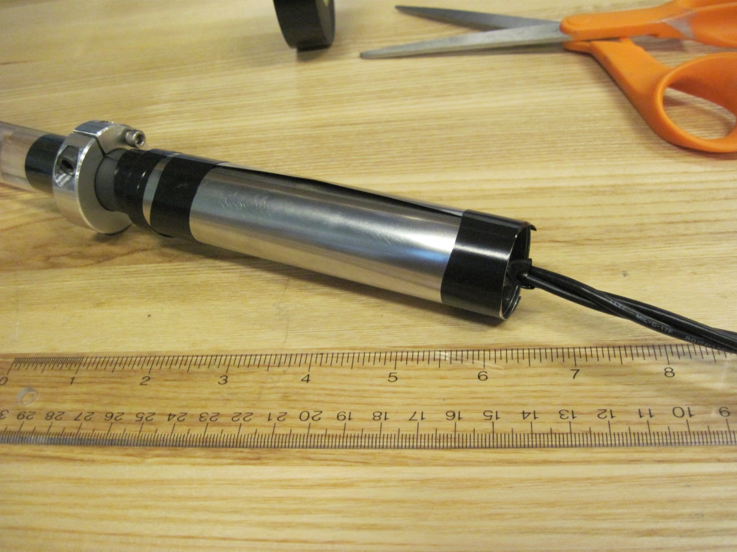
Fold over edge of metal

- Over-wrap the entire length of Mu Metal as shown:
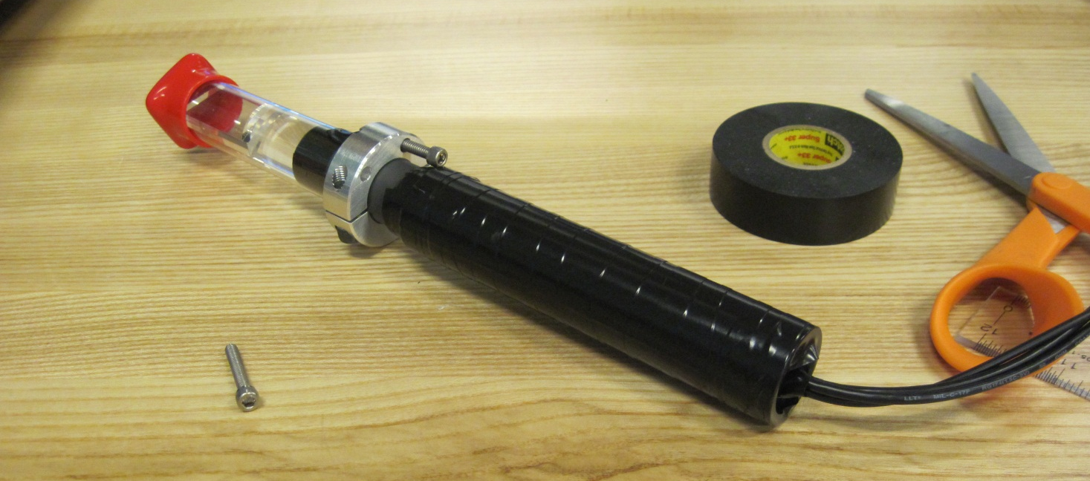

We still need a rubber end cap- see following photo

Concept cap- cable exit diameter will be larger due to the larger fire-rated cables:
