HodoScope PMT High Voltage Cable and Signal Cable Prep Guide
- Signal Cable- two per PMT
  - Cut each cable to 18” length from the exit of connector housing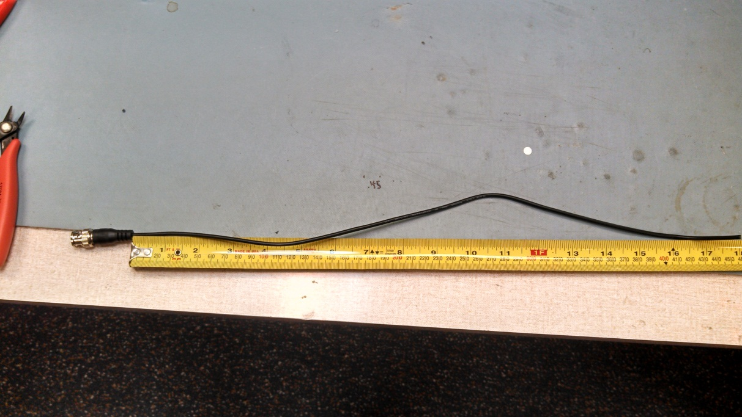
  - Cut 18” of Flame Retardant Wrap; feed signal cable through wrap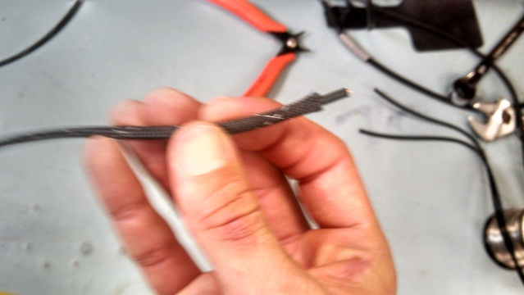
  - Strip 0.6” of outer insulation from cut end using cable stripper(16 Gauge) 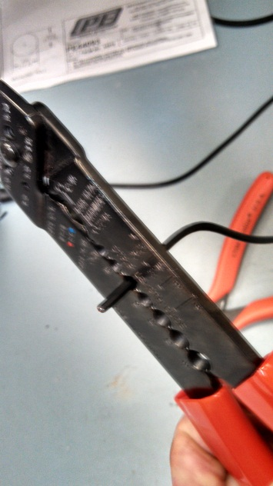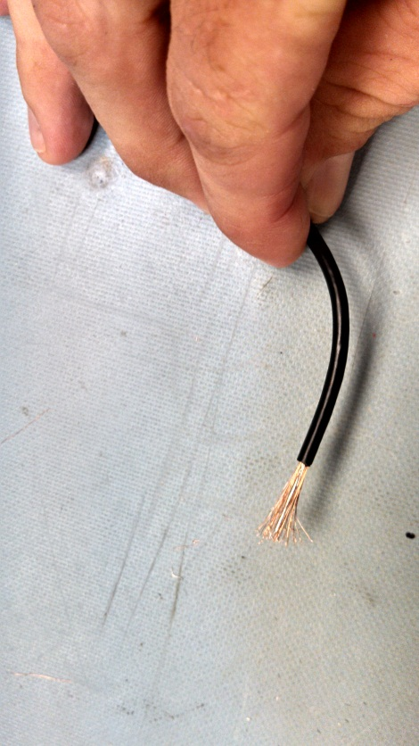
  - Separate and twist copper braid to form separate stranded cable; remove foil lining from center conductor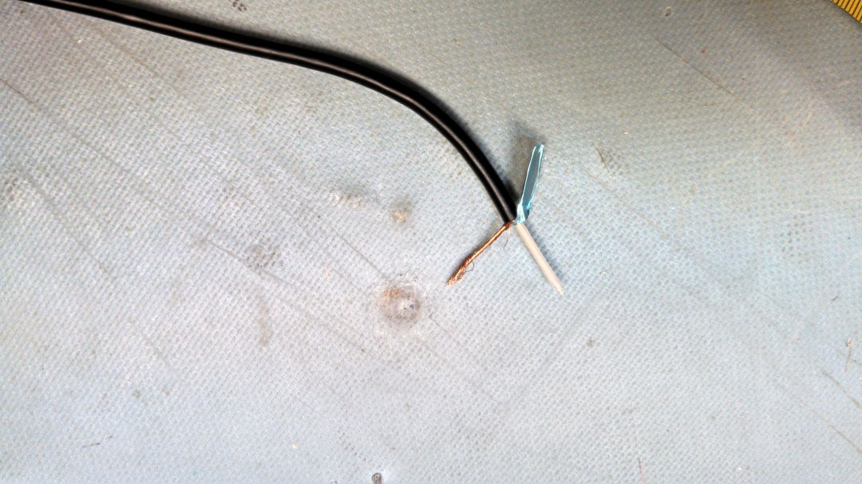
  - Ready to solder to PCB
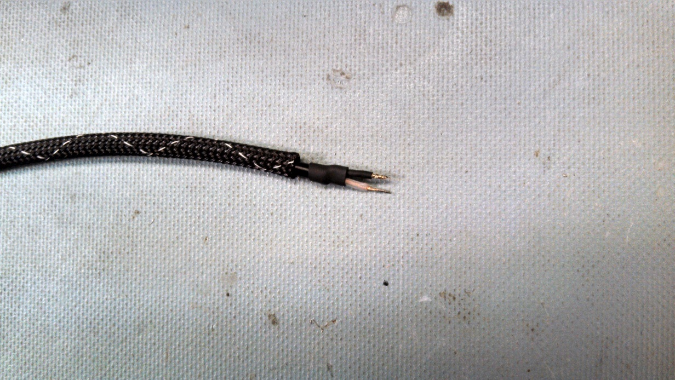

- High Voltage Cable- 1 per PMT
  - Cut each cable to 19” length
  - Feed nut, washer, and gasket onto cable, per Pasternack assembly guide http://www.pasternack.com/images/ProductPDF/PE44093.pdf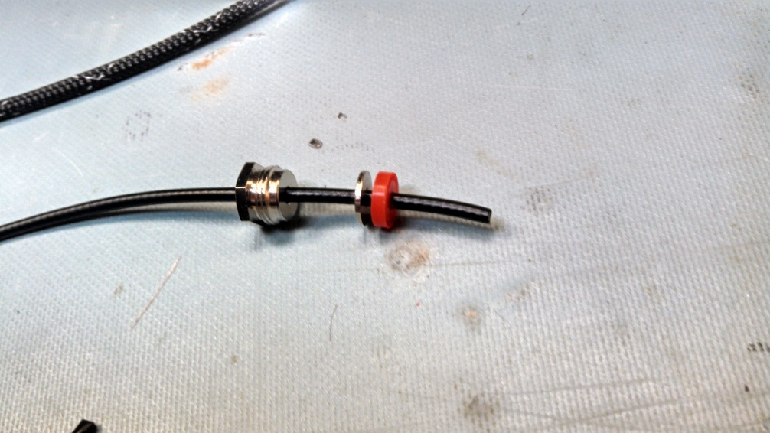
  - Cut .45” of insulation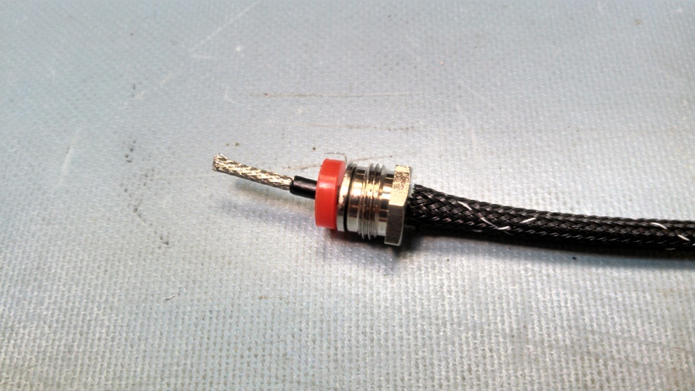
  - Feed Clamp, and form braid over clamp to secure components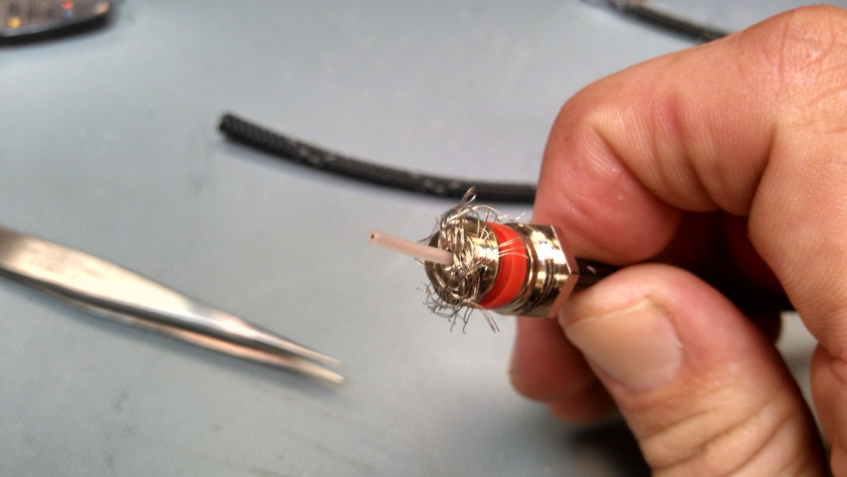
  - Cut and feed 18” of Flame Retardant wrap onto cable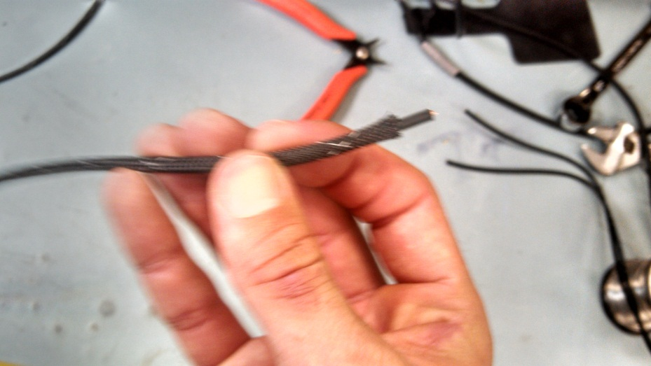
  - Strip 0.6” off base end of cable, form braid into separate strand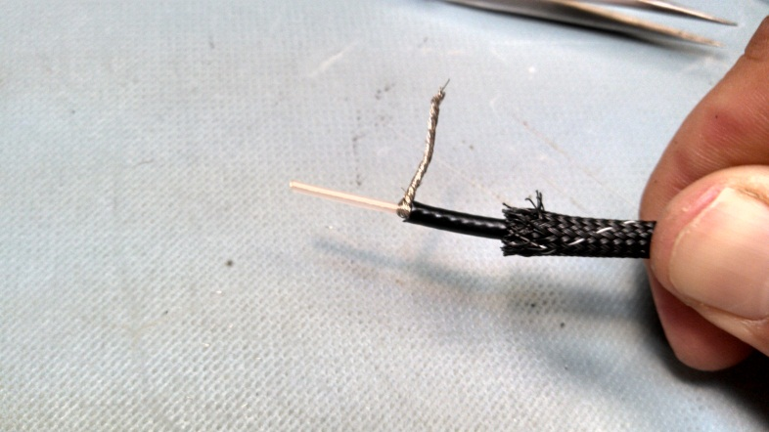
  - Assemble bulk head nut, gasket, and lock washer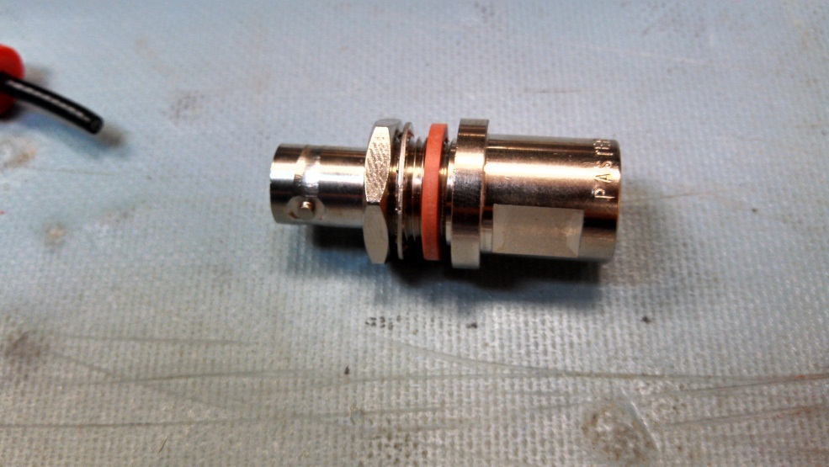
  - Place bulkhead, insulator, and contact in zip lock bag for solder assembly 